**STability Evaluation Tool (STET) 稳定性评估工具 (STET)**

**Summary 摘要**

The purpose of STET is to allow engineers to evaluate the passive stability of articulated (combination) vehicles using a simple Matlab tool. The basis of the analysis is the eigenstructure of the passive vehicle, when operating in the linear region. The designer can freely set a number of high-level parameters:

STET 的目的是让工程师使用简单的 Matlab 工具评估铰接（组合）车辆的被动稳定性。分析的基础是被动车辆在线性区域运行时的特征结构。设计人员可以自由设置一些高级参数：

* number of units
* distance between articulation joints
* mass and yaw inertia of each unit
* position of CG in each unit
* number and location of the axles within each unit
* damping coefficients for each articulation joint
* tyre properties – specify each axle cornering stiffness
* 单位数
* 铰接关节之间的距离
* 每个单元的质量和偏航惯性
* 每个单元中 CG 的位置
* 每个单元中轴的数量和位置
* 每个铰接关节的阻尼系数
* 轮胎特性--指定每个车轴的转弯刚度

The eigenstructure gives frequency and settling times for each mode, picks out any unstable modes and animates the mode shape for any selected mode. This allows the designer to have a better intuition of how poor stability will manifest itself.

特征结构可提供每个模式的频率和稳定时间，找出任何不稳定的模式，并对任何选定模式的模式形状进行动画演示。 这样，设计人员就能更直观地了解稳定性差的表现形式。

The tool is intended as a way to explore different vehicle configurations and design concepts. The underlying model is relatively simple and should not be used outside the linear region of the tyres.

该工具旨在探索不同的车辆配置和设计理念。基础模型相对简单，不应在轮胎线性区域之外使用。

Input data is in spreadsheet format (STET input data2.xlsx) with different cases labelled in clearly marked blocks. The blocks can be arranged anyway in the spreadsheet, but the same format should be used. Keywords (in upper case) cannot be changed, but the data can be edited within these blocks. In the example, a 5-unit ART comes with baseline data (CASE 1), a 4-unit ART joint damping removed (CASE 2), a 4-unit ART with reduced cornering stiffness at the tyres (CASE 3), and a 3-unit ART with increased mass for each unit. The changes are highlighted but this is just to improve visibility, STET ignores the highlights. Unit number for each case can be set from 2 to 5, and cases with different numbers of units can co-exist in the same simulation. But CASE 1 should have the most units, for comparison purpose later. And obviously, this includes simulations with all cases of the same numbers of units.

输入数据采用电子表格格式（STET input data2.xlsx），不同的情况标注在清晰的块中。电子表格中的区块可以任意排列，但应使用相同的格式。关键字（大写）不能更改，但数据可以在这些区块内编辑。 在示例中，5 单元 ART 附带基准数据（CASE 1），4 单元 ART 取消了联合阻尼（CASE 2），4 单元 ART 降低了轮胎的转弯刚度（CASE 3），3 单元 ART 增加了每个单元的质量。更改会突出显示，但这只是为了提高可视性，STET 会忽略突出显示。每种情况下的单位数可设置为 2 至 5，不同单位数的情况可在同一模拟中同时存在。但 CASE 1 的单位数应该最多，以便以后进行比较。显然，这包括所有单位数相同的情况下的模拟。

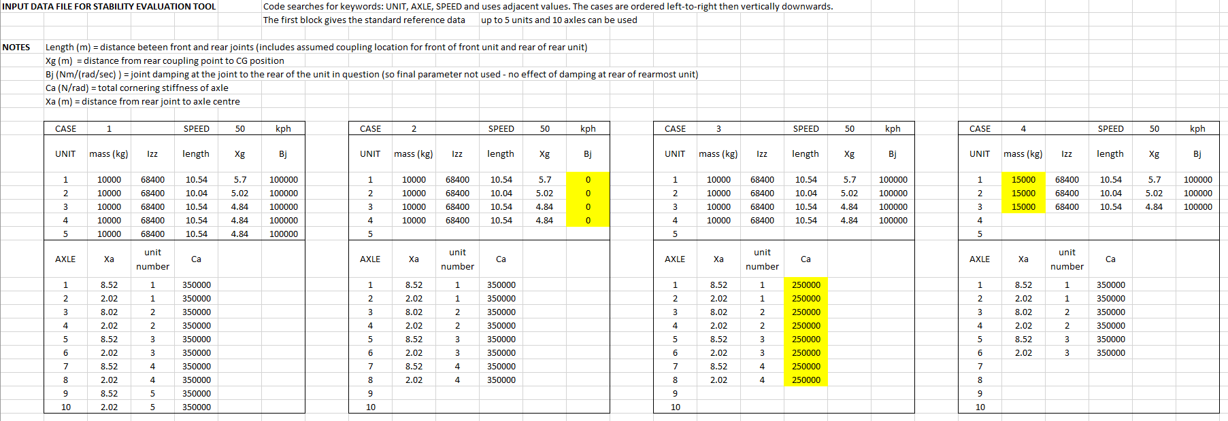

The name of the .xlsx file can be changed in the Matlab file STET.m

可在 Matlab 文件 STET.m 中更改 .xlsx 文件的名称。

Run the file STET.m to check the stability performance and animate the least stable (including unstable) mode. For the example data the following results are obtained:

运行 STET.m 文件检查稳定性能，并将最不稳定（包括不稳定）模式制成动画。示例数据的结果如下：

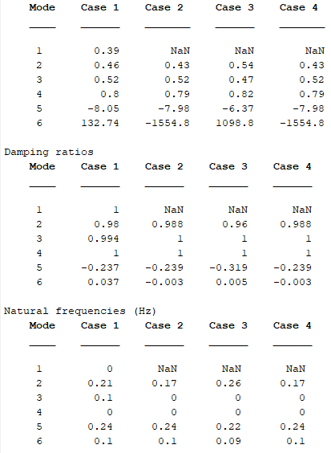

Since CASE 1 has the most units, then the most modes correspondingly. The mode index for the remaining cases are set according to CASE 1. For CASE 1, the mode numbers are assigned by Matlab in order of decreasing stability, with duplicated (complex conjugate) modes are removed as they carry no additional information (they correspond to negative frequencies and are physically the same as the positive frequencies). Then the mode index of the remaining CASES are re-assigned according the distance between its eigenvalues and CASE 1’s. For example, for mode 2 in CASE 1, if the 4th eigen value of CASE 2 is the closest one to 2nd of CASE 1, then mode 4 of CASE 2 will be re-assigned as mode 2. And if CASE 2 has less units, there should be some missing mode when all modes in CASE 2 has been re-assigned. Eigenvalues, eigenvectors, frequencies, damping ratios, and settling times are set to be NaNs for the table, or zeros for the trend plotting.

由于 CASE 1 的单元数最多，因此模式数也相应最多。对于 CASE 1，Matlab 将按照稳定性递减的顺序为其分配模式编号，其中重复的（复共轭）模式将被删除，因为它们不包含额外的信息（它们对应负频率，在物理上与正频率相同）。然后根据其特征值与 CASE 1 的特征值之间的距离重新分配其余 CASE 的模式索引。例如，对于 CASE 1 中的模式 2，如果 CASE 2 的第 4 个特征值最接近 CASE 1 的第 2 个特征值，那么 CASE 2 的模式 4 将被重新分配为模式 2。如果 CASE 2 的单元数较少，那么当 CASE 2 中的所有模式都被重新分配后，应该会有一些缺失的模式。在表格中，特征值、特征向量、频率、阻尼比和稳定时间均设置为 NaNs，在趋势图中则设置为 0。

Here for CASE 2 it is Mode 6 that shows the worst stability. Normally the (5%) settling time is the time it takes for it to settle from 100% to 5% amplitude (amplitude to reduce by a factor of 20). The negative settling time for unstable Mode 6 indicates that in Case 2 the instability is quite slow, it takes 1554.8 seconds for the amplitude to grow by a factor of 20. Similarly, a damping ratio close to zero indicated borderline instability, while larger negative damping ratio for Mode 6 in Case 2 shows that the instability is more serious.

在案例 2 中，模式 6 的稳定性最差。通常，（5%）稳定时间是指振幅从 100%稳定到 5%（振幅减小 20 倍）所需的时间。不稳定模式 6 的负沉降时间表明，在情况 2 中，不稳定性相当缓慢，振幅增长 20 倍需要 1554.8 秒。同样，阻尼比接近于零表明不稳定性处于边缘状态，而情况 2 中模式 6 的负阻尼比较大，表明不稳定性更为严重。

The mode shapes are displayed in figure windows, e.g. for Case 2. The green figure shows the starting mode shape, while the black shape is the new position after 2 seconds. Clearly modes 2, 3, 4 are more stable, but mode 5, 6 grow in amplitude.

模式形状显示在图示窗口中，例如案例 2。绿色显示的是起始模式形状，黑色显示的是 2 秒钟后的新位置。很明显，模式 2、3、4 更加稳定，但模式 5、6 的振幅有所增大。

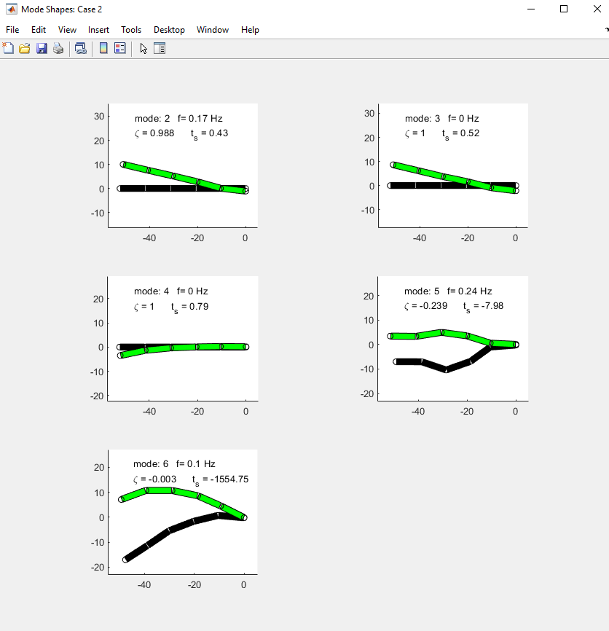

A final plot shows the trend between cases. For variables close to zero or one, zoom is needed to check the details.

最后一幅图显示了不同情况下的趋势。对于接近零或一的变量，需要放大以检查细节。

